## Chapter 1: Introduction

## Background

Quantum Computing is evolving technology developing exponentially fast and helps in solving real world problems at scale with many applications found from Drug Delivery to Supply Chain Logistics which couldn’t be solved by classical computers even bigger super computers can’t solve. It affects many industries & societies. Quantum technology up to 100 qubits are available by Google, IBM Quantum to meet the academic and industry applications.

Quantum Volume: A metric which measures error rates and capacity of a QC. It is the maximum of square of Quantum Circuits which are simulated successfully by a QC.

Quantum Circuits are independent of QC architecture. Quantum Advantage: QC will solve tough problems beyond classical computers.

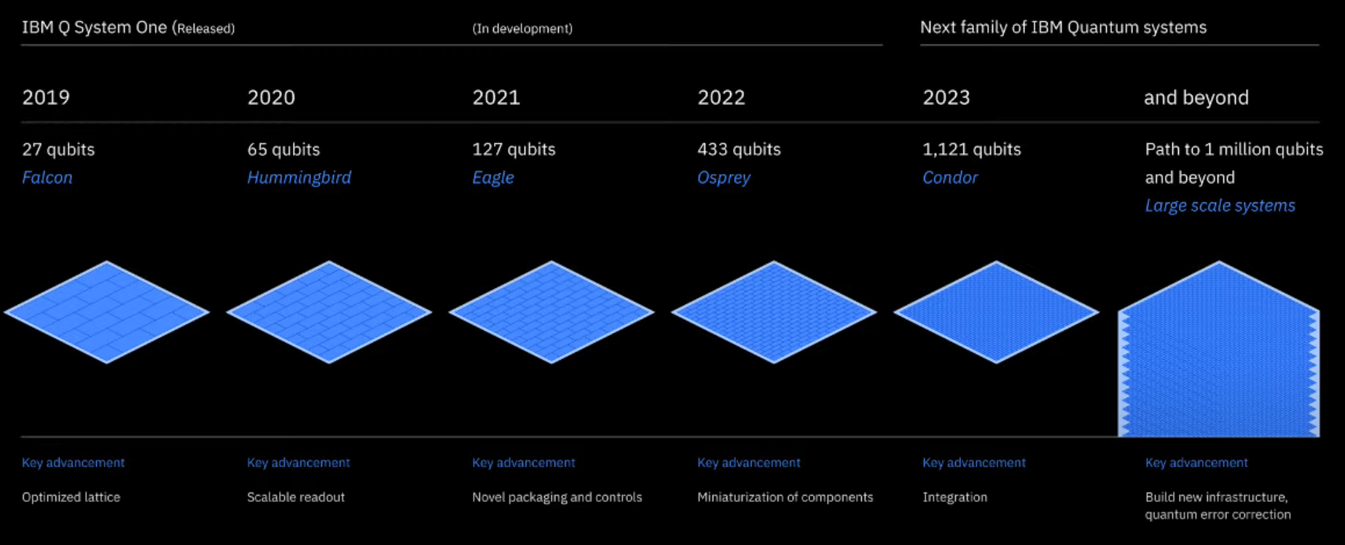

**Fig 1.** IBM Quantum & Qubits [1]

Quantum simulations of physical & chemical properties of molecules are vital to know the wide range of problems and found many applications in various domains from Quantum Chemistry, Information Sciences, Teleportation etc.

### Introduction to Quantum

Quantum: The study on interactions of matter with energies at the scale of atomic &subatomicparticles. Quantum draws differences with classical physics in many aspects & draws contradiction. Few instances are Quantization, Wave Particle Duality, Uncertainty principle etc.

Some of key concepts in Quantum are Wavefunctions, Observables, Entanglements, Tunneling.

### Quantum Mechanics:

Classical Principles doesn’t apply to Atomic & Subatomic particles as we go to microscopic levels. For example, let’s imagine a human is turning to his left & right at same time simultaneously or we can be at 2 places at same time both in university & at home. But this is possible in case of Subatomic particles due to Quantum.

Hence, this found many applications in the fields of Quantum Chemistry, Quantum field theory, Teleportation, Quantum Physics, Information Sciences etc.

Quantum Physics: According to Quantum, electron has both Particle [Electron Cloud with particle nature] and wave nature [Electron Cloud with Wave Nature]. Particle which consists of matter subatomic particles where electrons revolve in wave around proton and nuclei. It states that electron would be in 2 positions in same time. Here in below figure, we can’t determine the exact position of an electron unless using a wave function probability.

**Fig 2.** Electron Cloud with Particle Nature

Wave Function:

The probability of finding an electron from electron cloud can be determined by wave function. Here, square of wavefunction will determine the most likely presence of an electron. At this moment i.e. at maximum wave function, e- is no longer behaving as wave nature. It acts as particle which is called Superposition.

**Fig 3**. Quantum Wave Function of finding electron

Steps in measuring the probability of fining an electron:

1. Unobserved wave function: Original wave function
2. Wave function collapsed: By applying maximum of square of amplitudes.

**Fig 4**. Wave function & Probability of finding and electron

Ex: Spin a coin and it will have both Head & Tails position. When it settles / comes to rest, we can exactly say i.e. we can measure it’s position.

Similarly, e- in both particle and wave nature. The moment we measure it, it would be in particle form or in a wave form i.e. at super position state.

**Fig 5**: Electron measurement – Superposition State

**Fig 6**. Electron Cloud in Wave Nature

Famous example is Schrodinger’s cat experiment:

A cat in a box with poison may/may not die. Probability is 50 % - 50 %. It’s in superposition state now. If we unbox, i.e. we are trying to measure it’s state. It can be 0% or 100% which has a single state Called Wave Particle duality.

Understanding from Double slit experiment:

Single Slit: On passing electrons through a single slit, it forms a single bright fringe on screen. It acts as particle nature.

Double Slit: When electrons passed through two slits, it forms two bright fringes. Still it indicates particle nature of electrons.

**Fig 7.** Single & Double Slit Electron Screen

Single slit: On Passing particles 🡪 1 line of particles / wave 🡪 1 line of wave is formed

Double slit: On Passing particles -🡪 2 lines of particles/ wave -🡪 interference is formed

As per Quantum: If we pass particles through single slit, it forms a single bright fringe. But when we pass particles through double slit, still it interferes and forms interference patterns.

**Fig 8**. Single fringe & Interference pattern

On passing Waves:

Single slit: 1 line of particles is formed on screen.

Double slit: interference is formed. But how Though we have passed particles, still interference is formed which must be formed in case of wave. As e- have wave nature.

This concludes that electron has both particle nature and wave nature [17].

Quantum Entanglement:

Two particles 9said to be in entangled and values are opposite in nature (which travels more than speed of light)

Ex: Tossing a coin result in H –T i.e. yes – no, electron spin in upwards or downwards.

**Fig 9.** Spooky Action at a distance

A/c to Theory of relativity, nothing can travel at speed of light. But information between entanglement particles is possible. Einstein termed this as **Spooky action at a distance**.

[19] No communication is required between 2 particles & spins are fixed while particles are created.

Ex: Hand gloves in 2 different boxes will be predefined as Left Glove in Box & Right Glove in another box. Hence here no communication is required.

A/c to John Bell experiment proved that “There’s need to set particle spins when they are entangled.

“Spin of particles is not decided based on its entanglement.” Which devaluated Einstein’s **Spooky action at a distance.**

By using this Quantum Entanglement principle, Quantum computers are being developed.

Whenever particles are being observed, it behaves as particle & without observer, they behave as wave.

Quantum Teleportation:

Quantum teleportation is transferring of information from one location to another i.e. sender to receiver through Quantum particles [18]. Process involved is:

1. Sender and receiver will be in quantum entanglement. This particles relation can’t be explained by classical physics.
2. Sender measures the entangled Quantum Particle and uses a classical way of communication.
3. Receiver will do calculations for the received entangled particle and change it’s state matching with sender
4. Now, both sender and receiver will have same quantum information.

**Fig 10.** Quantum Teleportation

### Quantum Materials

Materials that exhibit quantum mechanical properties whose behavior is determined by laws of Quantum Mechanics at macroscopic levels. Number of materials are used for Quantum Computing applications like Super conductors, Semiconductors, Topological materials, Magnetic Materials, Photonic Materials, Color Centers etc

Super Conductors: Materials which conducts electricity with zero resistance and it suits for Quantum Computers as it allows the flow of Qubits without any loss. Ex: Niobium, Aluminum, Yttrium Barium Copper Oxide [YBCO] [2].

Semi-Conductors: Materials whose conductivity lies between conductor and insulator. This is most ideal and suitable to use in Quantum Computers due to ease of control over Qubits through electric fields.

Ex: Silicon, Gallium Arsenide, Germanium

Topological Materials: These materials which have unique topological structure with special properties. For instance, materials are insulated [3] on top and will be conducting from inside. This has use case in preventing Qubit interactions with environment [4].

Ex: Graphene, Tellurium, Bismuth Selenide

Color Centers: These are impurities in crystals which traps holes or electrons. Due to this, these are used as ideal materials in Qubits. Ex: Nitrogen Vacancy (NV) centers, Silicon Vacancy centers [5].

Other Materials like Magnetic Materials have it’s electron spins which can are used in qubits to store information. This can represent Quantum States of Qubits. Ex: Spin glasses, rare earth magnets. Photonic materials like Silicon Materials and Quantum Dots, Organic materials i.e. Graphene can be widely used in Quantum Computers.

### Current Trends in Quantum Computing

Quantum applications found versatile from Supply Chain Logistics, AI & ML, Battery technologies such as Li- Air batteries, Drug Delivery & Discovery, Quantum Defects in Semi- Conductors, Data encryption & Cryptography etc [6].

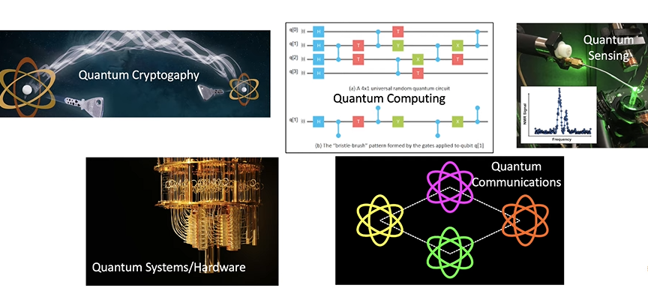

**Fig 11.** Rapid Growth of Quantum in various fields

As its applications are interdisciplinary, potential use cases are many. It follows as, New Battery Materials [To advance the performance Li -Air], Electronic Materials [Quantum Spin Defect materials – 4H SiC], Improving Nitrogen fixation, Chemical Observable prediction, Protein Folding etc.

Drug Discovery in Chemistry:

Instance of Quantum Advantages is, in general, to attach a particle to a molecule and simulate the complex molecule is not possible in classical computer as number of states needed to keep track of all its interactions grow exponential

Health Care and diagnostics:

Deadly disease of cancer in detection and diagnosis can be done by classification, clustering with ML. QC can potentially improve the quality of results could be able in identifying complex structures like DNA, RNA, Proteins.

Fraud Detection in financial transactions and risk detection.

Recent developments can be seen in Quantum Cryptography, Quantum Sensors etc. can be seen as products in market. Algorithms, dated back for 30 years like Quantum Algorithm for factorization which solves at exponential speedup with Quantum Computing.

Searching for unstructured data base, pattern matching, optimization etc. can be made faster and more accurate through Quantum.

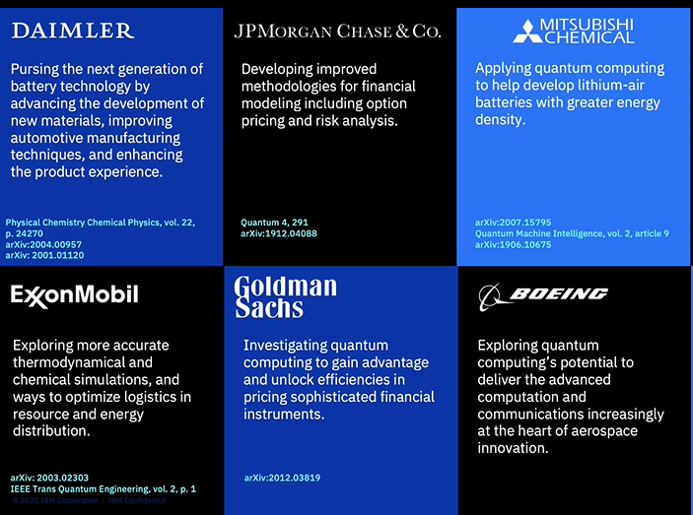

**Fig 12.** Real World Application of Quantum Computers[6]

Li -Air Simulations in Quantum Computing:

Lithium Air molecules can be effectively simulated in QC. As it found many applications in Energy systems especially Li-Air batteries, current trends are more on Simulating Li-Air molecules through Qiskit – IBM Quantum Q.

In 2021, accuracy of 0.01 kcal/mol is achieved. Specific energy is still being determined and it has an estimation of 5,000 to 11,000 Wh/kg. This is huge and far apart from classical values i.e. 250Wh/Kg which indicates Li-Air batteries have much potential than current.

### 1.5. Classical Computer v/s Quantum

There are key differences in defining, measuring of Classical Concepts when compared to Quantum [7].

Key differences:

|  |  |  |
| --- | --- | --- |
|  | Classical | Quantum |
| Wave particle Duality | Objects can be either in way state or in particle | Objects will be in Both States |
| Superposition | Only one state at a time | Exists in superposition of States |
| Entanglement | Objects are Independent of each other | Linked to other object’s state called Entangled |
| Uncertainty Principle | Exact position and momentum can be determined exactly with accuracy | In Quantum, it’s highly impossible to determine the exact position and momentum of a particle accurately |
| Wave Function | Position and momentum is used to determine the state of an object | Wavefunction is used to determine the state of an object |

**Table1.** Classical V/S Quantum

In classical, objects are represented in Bits: 0 & 1

Here, b = {0,1} defines a definite state

In Quantum Computing represented as Vectors

States (Unit Vectors): |0⟩ and |1⟩

Superposition (Linear Combination): **α**|0⟩ +**β** |1⟩

|q⟩ = **α**|0⟩ +**β** |1⟩

**|0**⟩ **= | α |^2**

**|1**⟩ **= | β|^2**

It gives a probability i.e., state is probabilistic.

Gates:

In Classical Computing measurements are represented in form of Gates ir AND, OR, NOR

Ex:

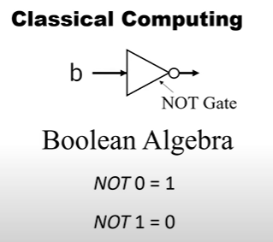

**Fig 13 & 14.** NOT Gate, AND Gate

Operations performed on gates in classical computimg are irreversable.

In classical Computing, linear in size of input N

In Quantum Computing;

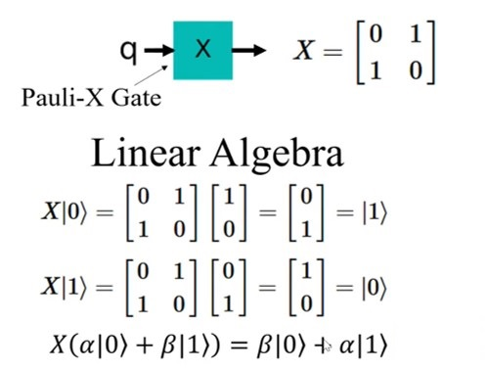

**Fig 15.** Pauli-X Gate

In Quantum Computing, it’s exponential in size of input $2^{N}$. Operation is reversible[8]

Classical representation of Hydrogen for Ground State Energy:

From Classical values, we can calculate Ground State as En. Where Z=1 for Hydrogen Atom and n represents state. Here n= 1

We get En = - 0.5 Hartrees which is almost equal to -13.6 ev. As electron is traversing to higher orbits it will absorb energy and energy levels will increase in orbital levels i.e. n at maximum values.

**Fig 16.** Hydrogen Spectral Lines & corresponding Energy Values

### 1.6. Literature review:

### 

[17] Quantum draws a major difference in studying the interactions at energy levels with matter at classical levels. For instance, electron will behaves as both particle nature and wave nature and the moment we try to measure it’s probability, it superimposes and behaves as particle. Hence it draws Wave Particle Duality. Through Double Slit experiments, tough we sent particles, they form multiple interference bright fringes stating them as they possess wave nature & the moment an observable is present it behaves as a particle. Single electron passed through both slits together and interferes and forms multiple fringes. .This draws an interesting concept of wave particle Duality.

Through Max plank and Einstein, it’s concluded that Energy is Quantized. Later Louis de Broglie stated matter exhibits wave particle duality and All matter has a wavelength i.e. an object’s wave length is inversely proportional to it’s mass. Hence heavy masses have negligible which are negligible. Electron is minute still it’s wavelength has to be considered when compared in atom as it constitutes almost the size of an atom. Mathematical Model is required to describe this wave behavior of electron and developed Schrodinger’s equation.

[19] Whenever particles are created together or interacted, they are in Entanglement. It indicates if a electron’s spin is up, in some other state, it’s spin is Down. For which Einstein stated this as A Spooky Action at A Distance with Hand gloves demonstration. And later Bell’s experiment proved Spooky Action is wrong and there’s no need for particles to determine it’s state earlier & even they are in entangled state. This draws major application called Quantum Teleportation

[18] Application of this Quantum Entanglement found in building in Quantum Computers & in fast way of communication called Quantum Teleportation. New developments made from ISRO and tested Quantum teleportation for a range of 50m. This can scale up to infinite distances and finds faster way of communication.

[20] Quantum materials are being developed and one such room temperature super conductor material LK-99. Super conductivity of LK-99 is due to Structural distortions caused by substitution of Copper ions Cu2+ ions in insulating medium Pb.

[21] Within a semiconductor nanostructure, a new Quantum bit is formed. By using calibrated optical laser pulses, a unique energy is transformed, and a Qubit is formed. Scientists created a superposition state in a Quantum Dot between hole ground state and higher energy state. Hence it created superposition State i.e. Qubits will be in between state ‘0’ and state ‘1’.

[6] Quantum Computing is emerging into many fields including Information Sciences, Physics, Quantum Chemistry, Teleportation etc. due to it’s wide range of properties which found many applications. Many are trying to achieve Quantum Supremacy like Google, IBM-Qiskit etc. to solve problems more fatly and efficiently which can’t be solved through classical computer or may take many years to compute. Quantum Volume plays a vital role in performance of Quantum Computers. It states that even though on more Qubits to get accurate results, Quantum Volume may be decreased due to noise preset and have to optimize using classical computers which is time consuming & also time taking. Concepts like Wave Particle duality, Superposition, Entanglements in Quantum V/S Classical have been studied. Availability of different Quantum Devices with different Qubits and processors at IBM – Quantum are studied & used to differentiate Ground State Energy values.

[14] Different Quantum Algorithms were developed to various applications and few are interesting and impactful Algorithms like VQE, Shor’s, Grovers. Applications of QC in Molecular Analysis with use of Hamiltonian, Variational Quantum EigenSolver [VQE] to determine Ground State energy estimations and further calculations of Bond Length, Interaction Energies, reaction rates are studied. Li-Air Battery Simulations through Quantum Computing has much influence as Quantum values are much far better than Classical Values. This helps in building more efficient batteries.

[22] 4D – Meta Material. With development of 4D Metamaterial. This material will control energy waves on solid surfaces & helps in finding how can eaves propagate on surfaces & also can manipulate to expected path & it draws applications in QC in determining Qubits traversing.

[23] Quantum Leap – Discusses the importance of Quantum Sensors as modern world is with sensors for heat, light, movement measurements. This Quantum sensor is found applications in Robotic Transporters, and in influencing plant growth called “PAR: Photosynthetically Active Radiation.” As Quantum is measuring at atomic level, it could be implemented in Mobile robots to monitor, inspection purposes & in Autonomous vehicle systems like LiDAR.

[24] “Quantum Super Chemistry” termed for performing experiments on very small particles at very cold temperature levels to enable fast and precise reactions. It depends on the greater the density, the faster the reaction rates and collectively.

[25] “Quantum Echoes” Storing information plays vital role in storing and transforming data. Quantum echoes found application in storing data in form of Sound Waves. This is done by electrical translations of Quantum states into sound waves and Sound Waves to Quantum States. This allows for sorting Quantum information as QCs are developed using Quantum circuits. This Quantum echoes uses Phonons for storing Quantum information & store mechanical waves.

[26] Most important work being carried out is simulation of Li-Air particles using Quantum computing to enhance & calculate the specific energy values used in developing Lithium-Air Batteries. IBM and Mitsubishi Chemical simulated the initial reactions of Li & Oxygen on Quantum Computer to understand the mechanism of Li-Air batteries and found potential when compared to classical levels in practice is much more. As, noise levels are more, work is going on to find a stable state qubit system to simulation.

### 

### 1.7. The objective of the present work

Objective of the present work is to understand concepts of Quantum Computing and using Quantum chemistry applications, performing simulations on Hydrogen Molecules to determine below properties.

The main objectives of the present work are as follows:

1. Ground Sate Energy Estimation of Hydrogen Molecule.
2. Bond Disassociation
3. Exchange reaction of Hydrogen.
4. Determining Potential Surface Energy of Hydrogen Molecule.
5. Activation energy barriers & reaction rates.

## Chapter 2: Qubit & Qubit Systems

## 2.1. Qubit:

A Quantum bit i.e. Qubit is quantum measurement of a classical bit. In classical measurement information is represented in form of bits (1 or 0). In Quantum, it’s encoded in Qubits which are usually represented as ∣0⟩ ∣1⟩ A Qubit can be represented ∣0⟩ or ∣1⟩

Qubit State: *ψ*=*α*∣0⟩+*β*∣1⟩

Where *α & β* are complex probability of amplitudes [8]

Classical Bit (0, 1)

**Fig 17.** Classical Representation

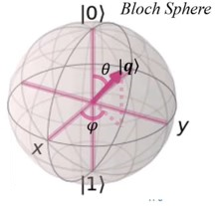

Qubit representation Bloch Sphere

**Fig 18.** Qubit Representation.

Examples of Single Qubits:

1. Polarization of a photon which has horizontal and vertical components can be represented as Single Qubit
2. Pauli’s Gate is an example of Single Qubit with set of three gates X, Y, Z

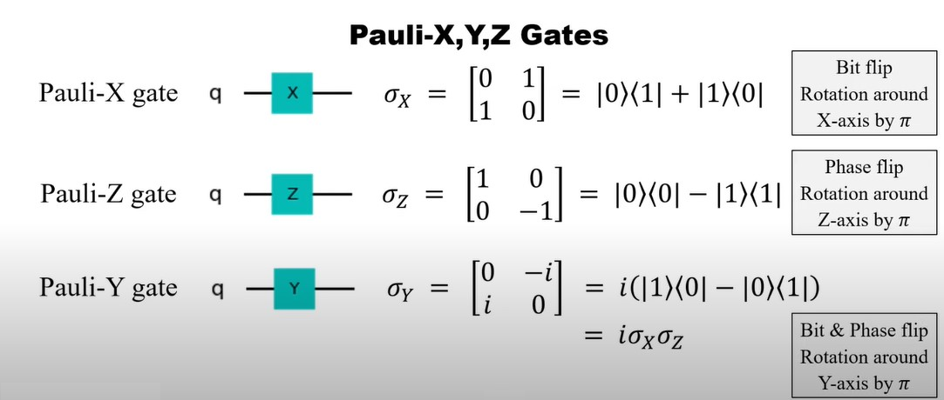

**Fig 19.** Single Qubit Pauli’s Gate

1. Spin of an Electron i.e. Up / Down side.
2. Charge of Superconducting Circuit: Positive charge and Negative charge.
3. Hadamard Gate: Especially used this transformation to make superposition of states.

Ex: If a qubit is in state   |0⟩, the Qubit would be in superposition of states |0⟩ and |1⟩.

**Fig 20.** Hadamard Gate of a Single Qubit

1. S Gate: Changes phase by ½.

## 

## 2.2. Quantum Circuit

Sequence of Quantum Gates applied on a set of Qubits. These Quantum Circuits are used in deriving Quantum Algorithms [11] which are further used as transformations in Quantum Computing.

They are represented in nodes and lines where nodes are gates and lines are Qubits in Quantum Environment i.e. Lab/ Composer.

Example of Quantum Circuit implementing Pauli Gate & Hadamard Gate :

**Fig 21.** Implementation of Pauli & Hadamard Gate on Qubit

Example algorithms are Shor’s, Grover’s, Simon’s, Deutsh-Jozsa Algorithms

Multiple Qubit States:

States which were defined over multiple Qubits are known as Multiple Qubit States or Multipartite Quantum States[9].

For n qubits, states are represented as 2n

Examples:

Bell States: These are maximum entangled states of 2 Qubit system and represented as below which indicates mostly corelated states are possible.

|ϕ+⟩, |ϕ−⟩, |ψ+⟩, and |ψ−⟩

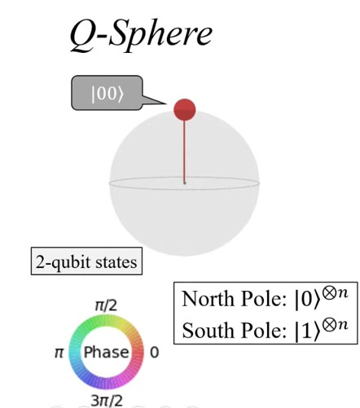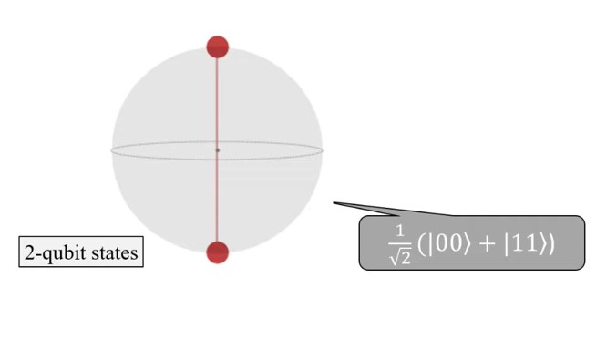

**Fig 22.** Qubit State representation

GHZ State: It’s a 3 Qubit system with special type of entanglement that’s used in Quantum Computing. Represented as,

|GHZ⟩ = (|000⟩ + |111⟩)/√2

**Fig 23.** Qubit State

**2.3. Quantum Simulator**

## There are multiple real time Quantum Simulators are available in IBM-Q Quantum computing Cloud with different Qubits and Different Quantum Volumes.

## Shots are defined as number of iterations for running our simulation in Quantum Computer.

## Interesting fact: the accuracy is not dependent on High number of Qubits available. It depends on the noise levels. The systems with least noise levels have more accurate values.

## Hence System with less number of qubits with less noise have high Quantum Volume[11].

## Fig 24. Availability of different Quantum Systems

## Example: ibm_nairobi

## Fig 25. IBM NAIROBI Quantum System

## This Quantum system has 7 Qubits with Quantum Volume 32 QV [12]

## No of shots / iterations can be made: 20000

## Maximum number of circuits: 100

## 

**Fig 26.** Maximum Shots & Circuit Error levels in IBM Q

**  
 Fig 27.** Noise levels Qubit & Circuit Diagram of Gates

Quantum Volume: QV is a single number metric that used to measure error levels, accuracy [11] usage of Qubits. It depends on various factors as mentioned in below figure.

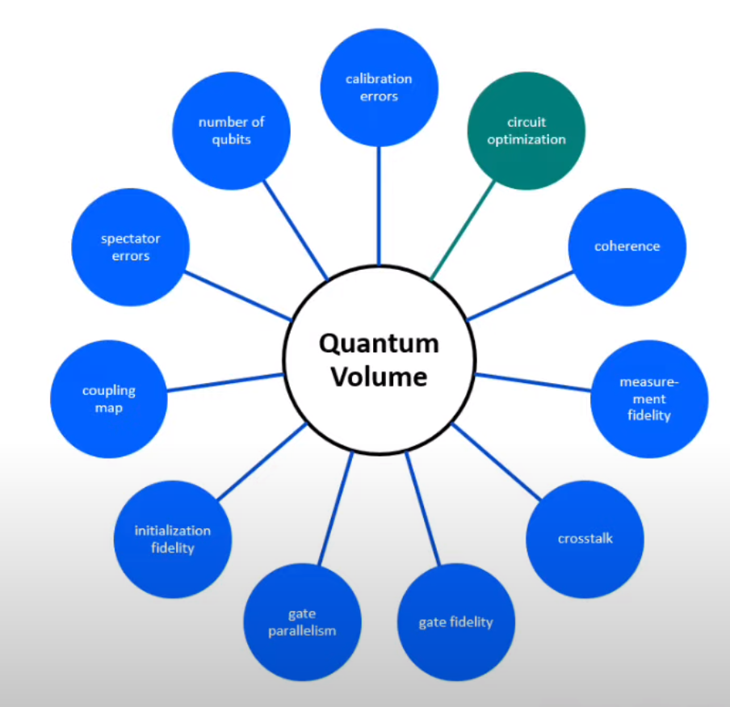

**Fig 28.** Quantum Volume (QV)

IBM – QSAM Simulator:

Quantum Simulator we are using to simulate Quantum Circuits is QSAM.

Features of QSAM:

Qubits: 32

Maximum Quantum Circuits: 300

Maximum Shots / iterations can be made: 20,000

Some other powerful Simulators:

|  |  |  |
| --- | --- | --- |
| System | Qubits | Quantum Volume |
| IBM_SHERBROOKE | 127 | 32 |
| IBM_PERTH | 7 | 32 |
| IBM_QUITO | 5 | 16 |
| IBMQ_JAKARTHA | 7 | 16 |
| IBMQ_LIMA | 5 | 8 |
| IBMQ_BELEM | 5 | 16 |

**Table 2.** Different Quantum Systems

Example Quantum Circuit of IBM_PERTH:

These circuits varies with systems and become more complex.

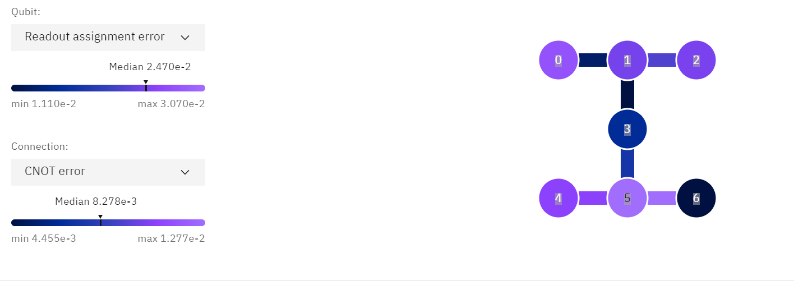

**Fig 29.** IBM_PERTH

**Fig 30.** Qubits & Error Assignments

## 2.4. Algorithms

Many Quantum Algorithms are tuned for different Quantum applications depends on their usage on various applications including Quantum, Mathematical Calculations like Fourier Transformations, Wave equations etc [13].

Examples:

Shor’s Algorithm: Used for factors large integral values.

Grover’s Algorithm: For searching Unstructured DataBase

Quantum Fourier Transform: This performs Fourier transformations on many Quantum States

Variational Quantum EigenSolver [VQE]: This is fundamental algorithm used in finding Ground State Energy of molecules and to calculate the properties of molecules as energy levels, inter atomic bond calculations etc

The Quantum Phase Estimation [QPE]: This is used to estimate the eigen values for given Hamiltonian.

The Quantum Monte Carlo [QMC] : This is used to simulate behavior of molecules at very high temperatures and pressures for an instance to determine properties of molecules at starts etc.

Here, we use Variational Quantum Algorithm to estimate Ground State Energy of Hydrogen Molecule

## 2.4.1. Variational Quantum EigenSolver [VQE]:

VQE is a Quantum Algorithm Q is a variational quantum algorithm which is used in determining ground state energies of molecules and other properties like inter atomic bond lengths, energies etc.

This works on classical computer to optimize variational ansatz nothing but a Quantum circuit and this is used in the calculations of ground state energies of small molecules like oxygen hydrogen etc.

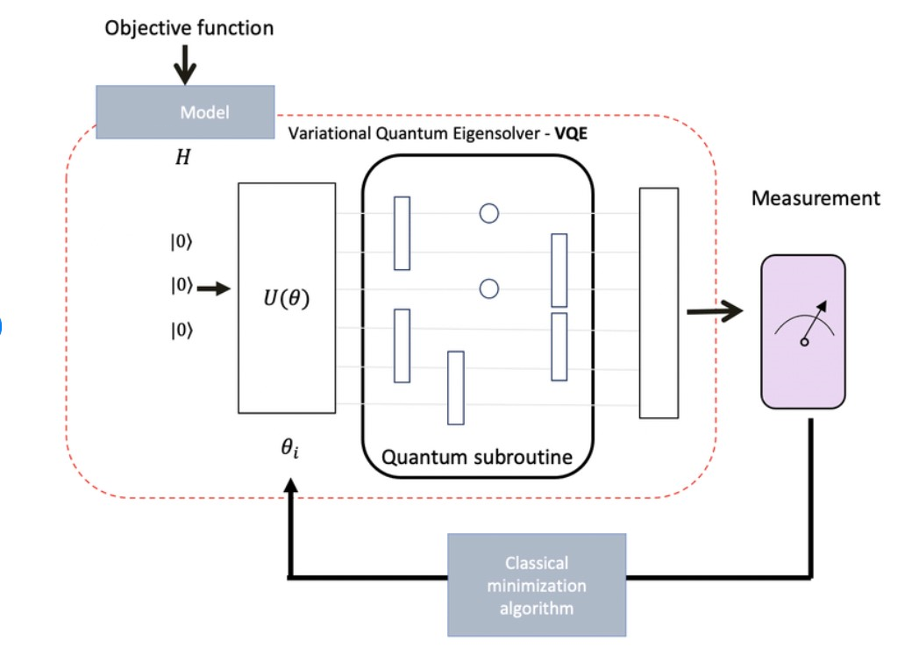

**Fig 31.** Working Principle of VQE

Working of VQE:

1. a classical computer creates Quantum circuit which is called as variational ansatz made up of series of gates.
2. Now classical computer sends this Circuit to Quantum computer to measure the outcomes of ansatz and quantum computer sends the results back to classical computer.
3. Now classical computer optimizes the results sent by quantum computer for good approximation of ground state energy values.
4. Step 2 and step 3 will be repeated based on number of shots provided i.e of iterations based on a Quantum Computer.

Limitations:

Though Variational Quantum EigenSolver is efficiently used in quantum chemistry still it has few drawbacks.

1. It can't be used for large molecules because in large molecules, number of qubits will be increased exponentially that means, number of gates will be increased as exponentially resulting in higher computational timing.
2. The ansatz choice should be made correctly, else it may not result in accurate Ground State Energy.
3. Error rates depends on Quantum Gates depth i.e. as gates increases, circuits will also increase.

## Chapter 3: Result and Discussion

### 3.1. Building of Electronic Hamiltonian

The inputs of Variational Quantum EigenSolver [VQE] takes molecular Hamiltonian and Quantum Circuit prepared through Quantum States of the molecule [15].

Steps involved:

1. Specifying a molecule: Hydrogen Molecules symbol ‘H’ in a list
2. Nuclear coordinates of hydrogen molecule in atomic units have been defined in an 1 dimensional array
3. Electronic Hamiltonian is built by using molecular_hamiltonian function

Code:

*from pennylane import numpy as np*

*symbol = ["H", "H"]*

*coordinate = np.array([0.00, 0.00, -0.741, 0.00, 0.00, 0.741])*

*import pennylane as qml*

*H, Qubits = qml.qchem.molecular_hamiltonian(symbol, coordinate)*

*print("Number of qubits = ", Qubits)*

*print("The Hamiltonian is ", H)*

Output will be number of Qubits i.e. 4 & Hamiltonians in form of linear Pauli’s operators. Here, number of Qubits defines number of spin orbitals that is 4.

Output:

*Number of qubits = 4*

*The Hamiltonian is (-0.20394895100296642) [Z2]*

*+ (-0.2039489510029664) [Z3]*

*+ (-0.15014979594089145) [I0]*

*+ (0.16479021929872753) [Z1]*

*+ (0.16479021929872759) [Z0]*

*+ (0.11809725687997179) [Z0 Z2]*

*+ (0.11809725687997179) [Z1 Z3]*

*+ (0.16402676014719642) [Z0 Z3]*

*+ (0.16402676014719642) [Z1 Z2]*

*+ (0.1665811370574448) [Z0 Z1]*

*+ (0.17240192089615744) [Z2 Z3]*

*+ (-0.04592950326722463) [Y0 Y1 X2 X3]*

*+ (-0.04592950326722463) [X0 X1 Y2 Y3]*

*+ (0.04592950326722463) [Y0 X1 X2 Y3]*

*+ (0.04592950326722463) [X0 Y1 Y2 X3]*

The electronic Hamiltonian is made by defining coordinates of Hydrogen Molecule. Here we defined the coordinates as (x,y,z) = (0,0,0.741) indicating electron is in Z direction.

On comparison with reference [27], electronic Hamiltonian for the same 4 Qubit system is different and this can be due to differences in Co-ordinates or noise levels or due to simulation in another Quantum System. Here we used QSAM Quantum Simulator.

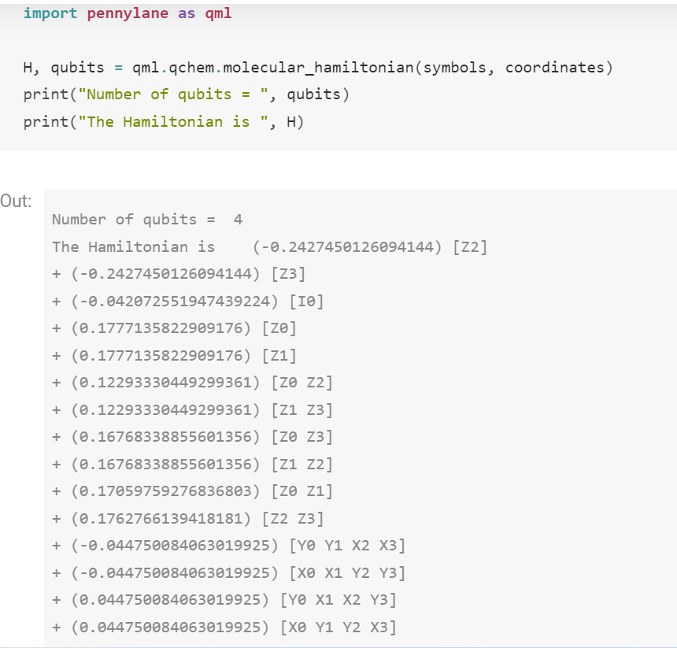

The outputs are expressed in function of Hamiltonian are in linear Pauli Operators & Number of Qubits = 4. Still Pauli’s operators are different with our Outputs.

### 3.1.1. Applying VQE on Hamiltonian

Implementing VQE on the prepared Hamiltonian using a pennylane simulator in Qiskit environment. Quantum Device has been defined with variable device.

*device= qml.device("lightning.qubit", wires=Qubits)*

Quantum circuit has to be prepared with trail state of molecule in form of



Fig 18: 2 Qubit Quantum Circuit

Where, θ variational parameter to be optimized. It’s because to find the best approximation to Ground State.

|1100⟩ represents Hatree-Fock (HF) i.e. 2 molecules at ground state.

|0011⟩ represents double excitation of HF state when these 2 electrons are excited to

qubits 0,1,2,3. These are the best rotational states of Qubits.

Hartree-Fock State: hf_state() function is used for generating a vector to represent H-F state.

*Electrons = 2*

*hf = qml.qchem.hf_state(Electrons, Qubits)*

*print(hf)*

Output: [1 1 0 0]

hf array is used as basis for qubit registry. Double excitation is performed on this 4 Qubit system as below by applying this.

*def Circuit(param, Wires):*

*qml.BasisState(hf, Wires=Wires)*

*qml.DoubleExcitation(param, wires=[0, 1, 2, 3])*

Cost function is defined by function expval() to determine the exceptional values of Molecular Hamiltonian for the ground state to be prepared.

*@qml.qnode(device, interface="autograd")*

*def cost_fn(param):*

*Circuit(param, Wires=range(Qubits))*

*return qml.expval(H)*

To optimize cost function, many optimizers available in pennylane simulator & we are going with gradient-descent optimizer [15]

*optimizer = qml.GradientDescentOptimizer(stepsize=0.4)*

Start the Hartee-Fock State by initializing θ to Zero

*theta = np.array(0.0, requires_grad=True)*

Optimizing the above Hamiltonian for 100 steps & tolerance o 106 for cost value function,

We determine ground state energy and circuit parameter.

Ground State Energy calculated = -1.13543138 Ha

Ground State Energy [27] = -1.13618883 Ha

Circuit Parameters calculated = 0.2426

Circuit Parameter [27] = 0.2089

Output:

Step = 0, Energy = -1.12439146 Ha

Step = 2, Energy = -1.13282037 Ha

Step = 4, Energy = -1.13481822 Ha

Step = 6, Energy = -1.13528812 Ha

Step = 8, Energy = -1.13539845 Ha

Step = 10, Energy = -1.13542434 Ha

Step = 12, Energy = -1.13543042 Ha

Final value of Ground-state energy = -1.13543138 Ha

Optimal value of Circuit parameter = 0.2426

From referenced data, Ground state values and circuit parameters are found to be:

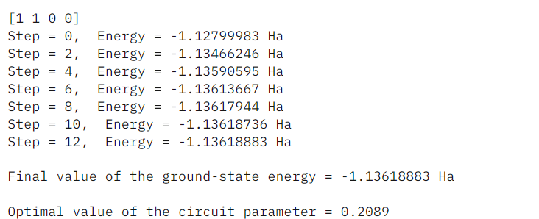

Plotting Graph between Ground State Energy and gated parameter θ :

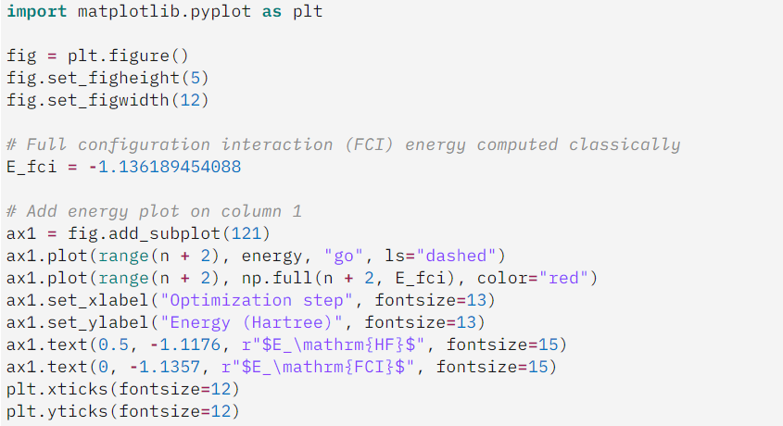

**Fig 32.** Graph between Ground State Energy (Hartree) V/S Optimization Steps & Gate Parameter

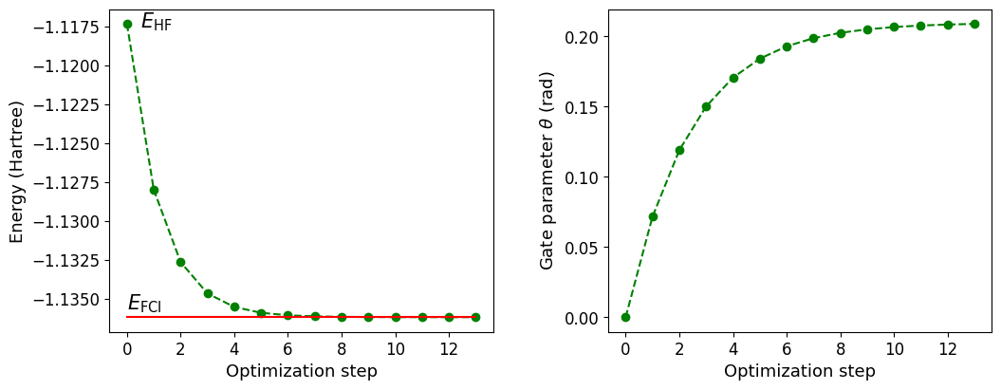

**Fig 33.** Graph between Ground State Energy (Hartree) V/S Optimization Steps & Gate Parameter – [27]

From above graphical data, the Ground state energy & States differs with Simulations here.

The Ground State Energy of Hydrogen Molecule is determined to be: **-1.13543138 Ha**

E_fci: Classical Energy value is: -1.136189454088 Ha

Optimal Value of Circuit Parameter θ: 0.2426 defines the state.

#### Potential Energy Surfaces

The transformation of molecules i.e. chemical reactions are characterized by energy levels that determines the probability of reaction to takes place. Here, we will determine reaction rates of H2, activation energy barrier, bond lengths.

Potential Energy Surfaces [PES] is energy of molecules at different positions of its atoms. As electrons shift towards/away from nucleus & proton due to light in weight resulting in instant new positions nothing but change in energy barriers. In Quantum, we will be solving only electronic Hamiltonian [16].

H(R)|Ψ⟩=E|Ψ⟩

E(R) Electronic energy is a function of Nuclear Energy

E(R)=⟨Ψ0|H(R)|Ψ0⟩ w.r.t Ground State |Ψ0(R)⟩

The potential energy function E(R) varies on distance of atoms of the molecule and helps in determining chemical reactions, transition states etc.

**Fig 34.** Potential Energy Surface of Di-Atomic molecule

Here, first atom is placed at initial position called ground state and energy is calculated. Next, atom is moved away and energy decreases and becomes to equilibrium state.

Further moving away from atom , the atom has much more distance such that it can dissociate. It’s called State of Dissociation.

Building potential energy, energy for fixed Nuclei is determined & adjust the positions of nuclei in increments & new energies are calculated. This gives E(R) i.e. raise in Potential Energy.

Bond Length & Bond Dissociation Energy of Hydrogen Molecule:

H2→H+H

It’s a 2 electrons in 4 spin orbitals. Hence we will use 4 Qubits. Hartree-Fork (HF) state is represented with lowest energy orbitals for two electrons |1100⟩. To construct Potential Energy Surfaces, we vary location of Nuclei and calculate energies of new positions.

H atom is kept fixed at origin and other atom is moved according to bond length. Hence, it’s only function of bond length.

For each bond lengths, Hamiltonian is constructed & optimize the quantum circuit to obtain ground state energy values. Bond lengths are varied form 0.5 Bohrs to 5.0 Bohr with step size as 0.25 Bohr.

Code:

Hamiltonian is built by using molecular_hamiltonian() function & optimized.

On Plotting graph between Total Energy & Bohr Radius.

**Fig 35.** Potential Energy Surface

This determines the Potential Energy of hydrogen molecule in two Hydrogen atoms. With help of this, bond length i.e. distance between 2 atoms, bond dissociation energy i.e. energy when atoms are far enough to dissociate are calculated.

Output:  
The equilibrium bond length is 1.5 Bohrs

The bond dissociation energy is 0.198772 Hartrees

Hence, the bond dissociation energy is calculated to be 0.198772 Hatrees & equilibrium bond length is 1.5 Bohrs.

Application of this Potential Energy Surfaces can be found in determining Hydrogen exchange reaction rates.

H2+H→H+H

There’s a transition state that needs to be broken for exchange of H.

Initially, H-H bond is broken and H atom forms interaction with other H atom thus results in H exchange. It depends on atomic distances.

**Fig 36.** Represents H2 🡪 H

**Fig 37.** Represents H + H 🡪 H

**Fig 38.** Represents H 🡪 H2

System consists of three electrons in six spin molecular orbitals. Hence it’s a 6 Qubit problem.

Hartree-Fock (HF) for 6 Qubit is defined as |111000⟩. It has one unpaired electron in atom H & spin multiplicity equals to 2.

Position of outer most atoms are being fixed and only middle atom’s position is changed.

In building Quantum Circuit, AllSinglesDoubles template is used for Single and Double excitation of gates.

Potential Energy Surfaces are plotted as Hartree (Total Energy) V/S Distance (Bohr) :

**Fig 39.** Graph between Total Energy V/S Atomic Distance

The minimum values of energies are the Ground state energies of outer most Hydrogens atoms and the variations of energies are due to movement in middle Hydrogen atom.

Activation energy can be determined with above Potential Energy Surface values.

Difference in energy of reactants & transition states is called as Activation Energy (Ea).

Ea=ETS−ER.

Output:

The activation energy is **0.027504 Hartrees**

Reaction rate (k):

Where, kB is Boltzmann constant

T is Temperature

A is potential Factor of reaction

The rate of chemical reaction depends exponentially on Activation Energy.

Example:

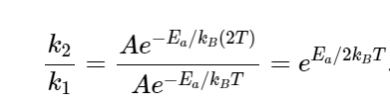

Let’s consider T = 300 Kelvin

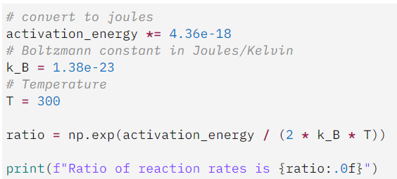

Ratio of reaction rates is 1948918.

The activation energy is doubled here and ratio of reaction rate is changed drastically.

Hence, Potential Energy Surfaces PES is calculated, and equilibrium bond length & bond dissociation energies are calculated to be 1.5 Bohrs & 0.198772 Hartrees.

Activation energies are found as 0.027504 Hartrees and reaction rate for double of activation energy is determined as 1948918.

## Chapter 4: Conclusion

The result and discussion of Ground State Energy Estimation of Hydrogen Molecule is determined by constructing a electronic Hamiltonian of 4 Qubits system & Variational Quantum EigenSolver [VQE] is applied & Energy is to be of -1.13543138 Ha when compared to Classical Value of -1.136189454088 Ha. Optimal Value of Circuit Parameter θ: 0.2426 defines the state of the electron. Differences in both Energy and State are found with reference data due to reasons like change in Coordinate values of Molecule, Noise Levels and Simulator system changes.

Potential Energy Surfaces [PES] has been calculated for H2 molecule by taking 2 electron system i.e. in 4 spin molecular orbitals for 4 Qubit system and plotted graphs between Total Energy and Bond length. With help of this, bond length i.e. distance between two atoms, bond dissociation energy i.e. energy when atoms are far to dissociate are calculated and values are of 1.5 Bohrs & 0.198772 Hartrees.

Activation energy Ea is determined to be 0.027504 Hartrees and by changing this energy twice, reaction rate is drastically increased, and ratio is found to be 1948918.

These applications can be further used for different Molecules like O2, H20, Li-Air. Further, Li-Air molecules can also be simulated using IBM – Quantum and more efficient energy values are achieved which has huge potential and applications.

## Chapter 5: References

[1] Road Map of Quantum Computing – NPTEL

<https://archive.nptel.ac.in/courses/106/106/106106232/>

[2] “**Superconductors: Physics and Applications."** By Daniel Tsui and J. R. Schrieffer. Princeton University Press, 2000

[3] “**Topological Insulators: Fundamentals and Applications."** By M. Z. Hasan and S.-C. Zhang. Princeton University Press, 2013

[4] “Topological Quantum Materials" by C. Nayak, S. Simon, A. Stern, M. Freedman, and S. Das Sarma (Reviews of Modern Physics, 2008)

[5] “**Color Centers in Materials for Quantum Technologies."**Edited by Alexander Galindo and Luis A. Orozco. Springer, 2017

[6] A Brief Introduction to Applications of Quantum Computing – Module1

[https://archive.nptel.ac.in/courses/106/106/106106232/#](https://archive.nptel.ac.in/courses/106/106/106106232/)

[7] Classical V/S Quantum: Quantum Computing for Beginners" by Patrick Hayden (O'Reilly Media, 2017)

[8] Quantum Gates and Circuits Module1 Lec8 – NPTEL

[https://archive.nptel.ac.in/courses/106/106/106106232/#](https://archive.nptel.ac.in/courses/106/106/106106232/)

[9] Quantum Gates and Circuits Module1 Lec9 – NPTEL

[https://archive.nptel.ac.in/courses/106/106/106106232/#](https://archive.nptel.ac.in/courses/106/106/106106232/)

[10] Quantum Circuit - Wikipedia: <https://en.wikipedia.org/wiki/Quantum_circuit>

[11] mod02lec10 - Programming using IBM Quantum Experience and Circuit Composer

NPTEL

[12] IBM NAIROBI – Quantum System

<https://quantum-computing.ibm.com/services/resources?system=ibm_nairobi>

[13] Quantum Algorithms in Chemistry: A Tutorial Introduction" by Daniel J. Egger (Morgan & Claypool Publishers, 2018)

[14] Quantum Algorithms – NPTEL Lec 21

[15] Pennylane.ai – A brief overview of Variational Quantum EigenSolver

<https://pennylane.ai/qml/demos/tutorial_vqe>

[16] Pennylane.ai - <https://pennylane.ai/qml/demos/tutorial_chemical_reactions>

[17] <https://en.wikipedia.org/wiki/Introduction_to_quantum_mechanics>

[18] [https://en.wikipedia.org/wiki/ Quantum_teleportation](https://en.wikipedia.org/wiki/%20%20Quantum_teleportation)

[19] [https://www.space.com/ 31933-quantum-entanglement-action-at-a-distance.html](https://www.space.com/%2031933-quantum-entanglement-action-at-a-distance.html)

[20] <https://quantumzeitgeist.com/worlds-first-room-temperature-superconductor-synthesized-could-impact-development-of-quantum-computing-and-qubits/>

[21] <https://scitechdaily.com/the-dawn-of-a-new-era-a-new-type-of-quantum-bit-achieved-in-semiconductor-nanostructures/?expand_article=1>

[22] <https://interestingengineering.com/science/synthetic-4d-metamaterial-solid-surface-waves>

[23] <https://venturebeat.com/data-infrastructure/quantum-leap-how-quantum-sensors-are-revolutionizing-robotics/>

[24] <https://www.livescience.com/chemistry/quantum-superchemistry-observed-for-the-1st-time-ever>

[25] Quantum Echoes: <https://scitechdaily.com/quantum-echoes-a-revolutionary-method-to-store-information-as-sound-waves/>

[26] <https://us.mitsubishi-chemical.com/battery-research-advances-quantum-computing-capabilities/>

[27] Building Electronic Hamiltonian - /pennylane.ai/qml/demos/tutorial_vqe

Other References:

<https://github.com/PennyLaneAI/qml/blob/master/demonstrations/tutorial_chemical_reactions.py>

QISKIT Documentation

IBM – Q: lab.quantum-computing.ibm.com